IOT Streetlight Controller System

Here we propose an IOT based street light monitoring and controlling system to ensure, low power consumption, consumption monitoring, instant faulty light detection and light dimming as per external lighting conditions. Our proposed system consists of smart street lights that have external light sensing that automatically turns on at desired intensity based on amount of lighting needed. The system also allows the controller/monitoring person to check estimate power consumptions as per current intensity of light as well as predict monthly power consumption. Also each of the unit has load sensing functionality that allows it to detect if the light has a fault. It then automatically flags that light is faulty and this data is sent over to the IOT monitoring system so that action can be taken to fix it. We here use IOTGecko iot development platform for the online system using the iotgecko api to transmit data and display online.

Block Diagram :
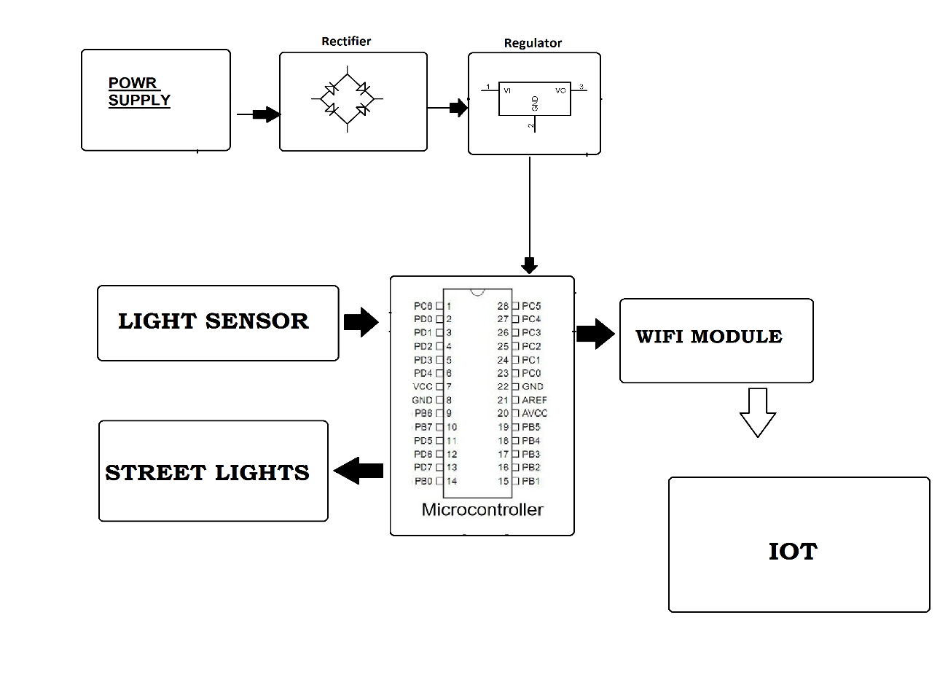

Hardware Specifications :
- Rectifier
- Regulator
- Power Supply
- Light Sensor
- Street Lights
- Wifi Module
- Atmega 328 Microcontroller

Software Specifications :
- Arduino Compiler
- Programming Language: C

